**MEMBERSHIP**

**APPLICATION FORM**

**Complete ALL SECTIONS using INK BLOCK CAPITALS and submit to a committee member either at a club meeting or at the field**

PERSONAL DETAILS

CLUB NEWSLETTER

To receive your club newsletter. please give your email

First Name

Surname

Address

E-Mail Address

Tick to join TMAC Facebook?

GDPR

The Club will keep the private data on this form on file.

We do not keep your credit card or bank details on file.

Data will be retained for up to two years once you leave.

Please indicate your acceptance by your signature below.

Contact a committee member for info and corrections.

Town

County

Post Code

2025 MEMBERSHIP REQUIRED

Mobile No.

Please Tick applicable memberships required.

Tick to join TMAC WhatsApp?

**TMAC annual (Dec to Dec) membership**

Date of Birth

Adult TMAC

Spouse / Partner TMAC

Junior (under 18) TMAC

£70

£60

£40

BMFA MEMBERSHIP

Non-flying TMAC

£25

Telford Model Aero Club is affiliated to the British Model

Flying Association, which provides our 3rd party

insurance. It is a mandatory requirement for TMAC flying

members. Proof of insurance is essential.

I am *not* a member of the BMFA

I am already a member of the BMFA

BFMA Membership No.

Please include your membership card with this

application form to ensure prompt processing.

CAA OP Number

CAA registration is required prior to flying

FLYING COMPETENCE

DECLARATION

I, the undersigned, agree to abide by all club rules and

safety regulations imposed at any time by the club

committee. and to above GDPR STATEMENTS (.Parent or

guardian to sign if applicant is under 18). Failure to comply

to club rules or guides may result, at discretion of committee,

If known, please define your equipment preferences

Tx Mode 1

Tx Mode 2

Electric

Plane

Helicopter

Jet

IC

Quad

Novice

'A' certificate

x

Some solo experience flyer, without *any* certificates.

'B' certificate BMFA Examiner

x

**Signature**

**Date**

Application and payment received with thanks.

Payment Method Transfer

Date of Membership Start

£

***Happy Flying***

**f r o m**

Name ........................................

**Telford Model Aero Club**

Committee Member

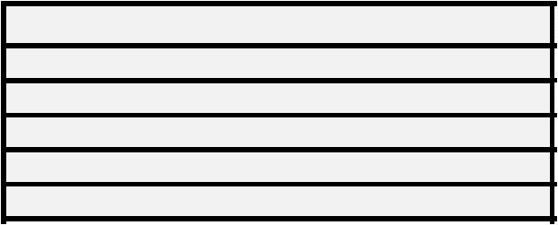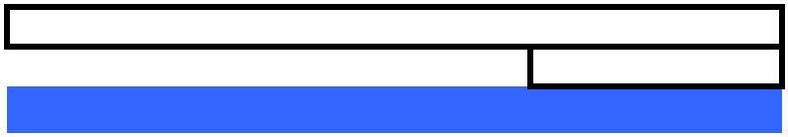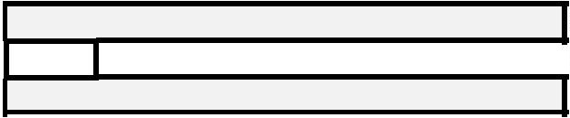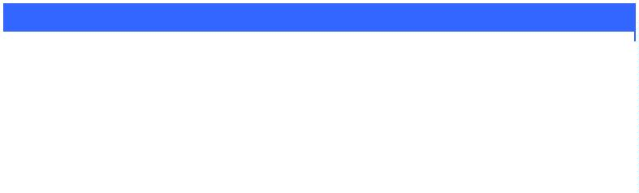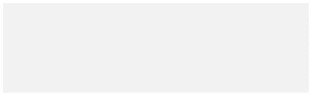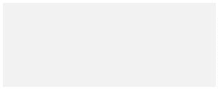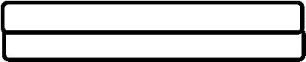



Payment via bank Transfer to

Telford model Aero club

Lloyds Bank

Sort Code **30-99-50**

Account Number **58674463**

**Please use your full name as thye reference.**



**Please Note TMAC no longer offers BMFA membership. BMFA Membership can be obtained at https://bmfa.org/join-us.**

p